**INFO 2302 Web Technologies**

**Exercise**

**JSON**

## Stringify a JSON object

1. Open your browser.
2. Right-click on your browser, and choose Inspect.
3. In Developer’s Tools, click on the **Console** tab.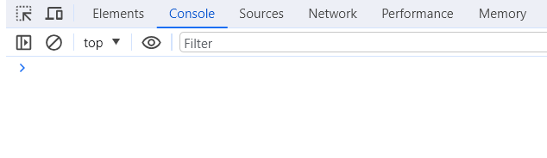
4. Type the following commands in the console:

let myObj = { name: "Ahmad", age: 25 };

myObj;

let myString = JSON.stringify(myObj);

myString;

## Parsing a JSON object

1. In the same console, type the following commands:-

const txt = '{"name":”Ahmad", "age":25}’;

txt;

const obj = JSON.parse(txt);

obj;

## Understanding asynchronous JavaScript using XMLHttpRequest object

1. Download exeJSON.zip from iTaleemc. Extract the compressed files (**xhr.html** and **content.txt**) into your **Exercises** folder.
2. Open **xhr.html** in VS Code. Run the program using **the Live Server** extension.A blue rectangle with white text

   Description automatically generated

The following output will be displayed.

1. Click on the **Change Content** button. The following output will be displayed.

## Understanding asynchronous JavaScript using fetch() API

1. Copy the following codes to VS Code and save the as fetch_hello.html in the same folder with xhr.html

<!--Example: using fetch. To run this program, follow the instructions in the exercise folder-->

<!DOCTYPE html>

    <html>

    <body>

        <div id="foo">

            <h2>Using fetch API</h2>

            <button type="button" onclick="changeContent()"> Change Content</button>

            <div id="result"></div>

        </div>

         <script>

            async function changeContent() {

                let file = "content.txt";

                let myObject = await fetch(file);

                let myText = await myObject.text();

                document.getElementById("result").textContent = myText;

            }

        </script>

    </body>

    </html>

1. Run the program using the Live Server extension.